To create a DynamoDB table, you can follow these steps:

1. Sign in to the AWS Management Console and open the DynamoDB service.

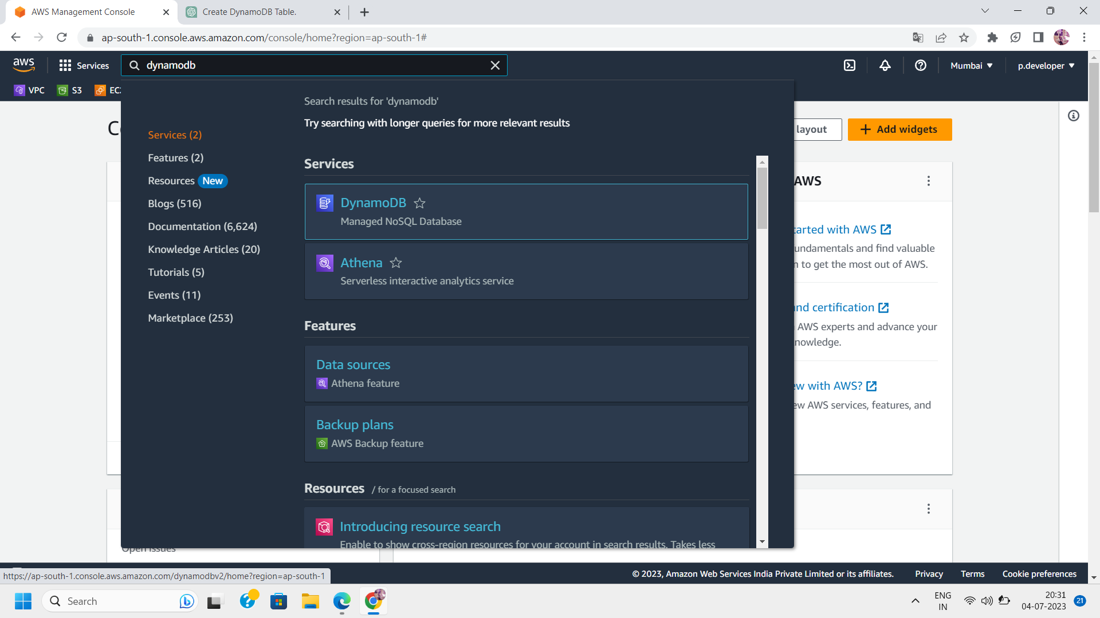

1. Click on "Create table" to start creating a new table.

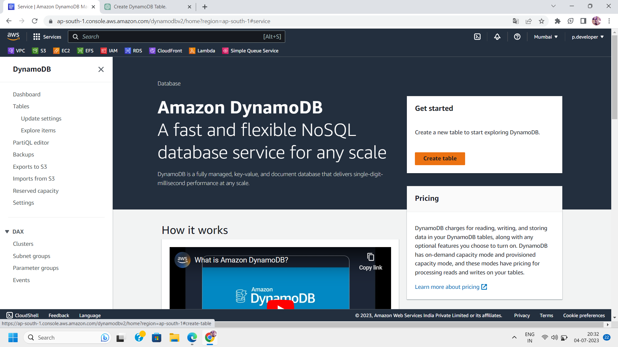

1. Provide a table name that follows the DynamoDB naming rules.

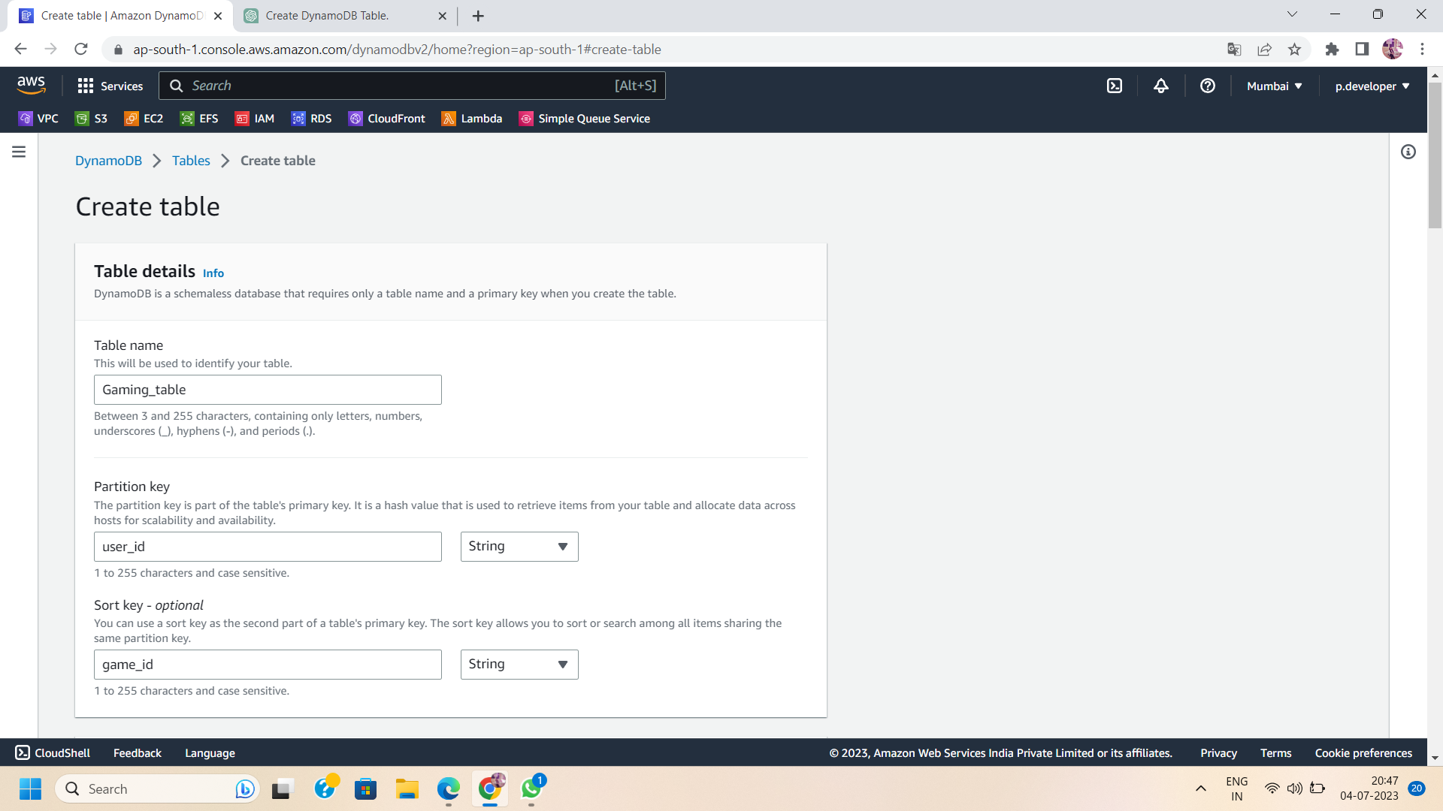

1. Specify the primary key for your table. The primary key consists of one or two attributes: a partition key and an optional sort key. The partition key is used to distribute the data across multiple partitions for scalability.



1. Choose the data type for each attribute in the table. You can specify different types such as string, number, binary, etc.For example, you could include attributes like "title" (string), "content" (string), "author" (string), "date" (string or timestamp), etc.

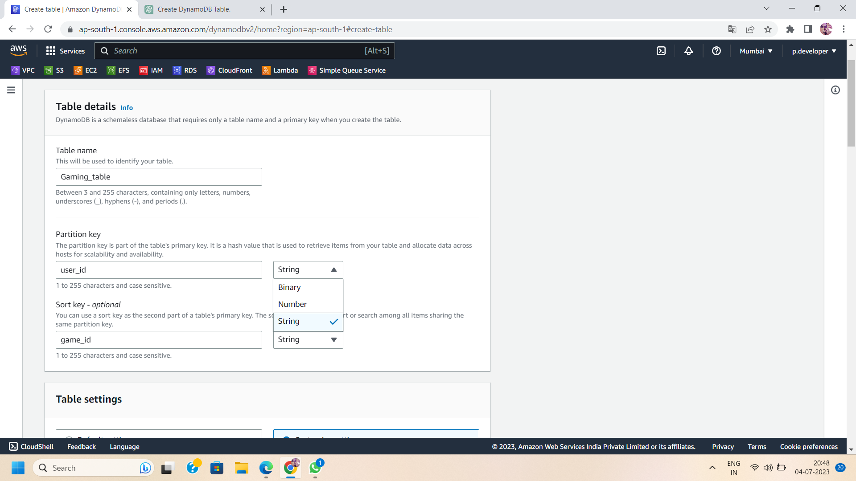

1. Configure the read and write capacity settings for your table. This determines how much read and write throughput capacity you provision for your table. You can choose to use on-demand capacity or provisioned capacity.

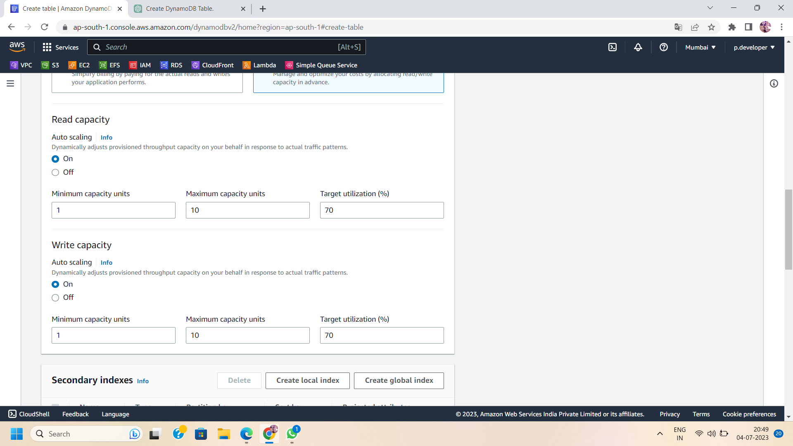

1. Enable any desired advanced features such as encryption at rest or global secondary indexes. These features provide additional functionality for your table.

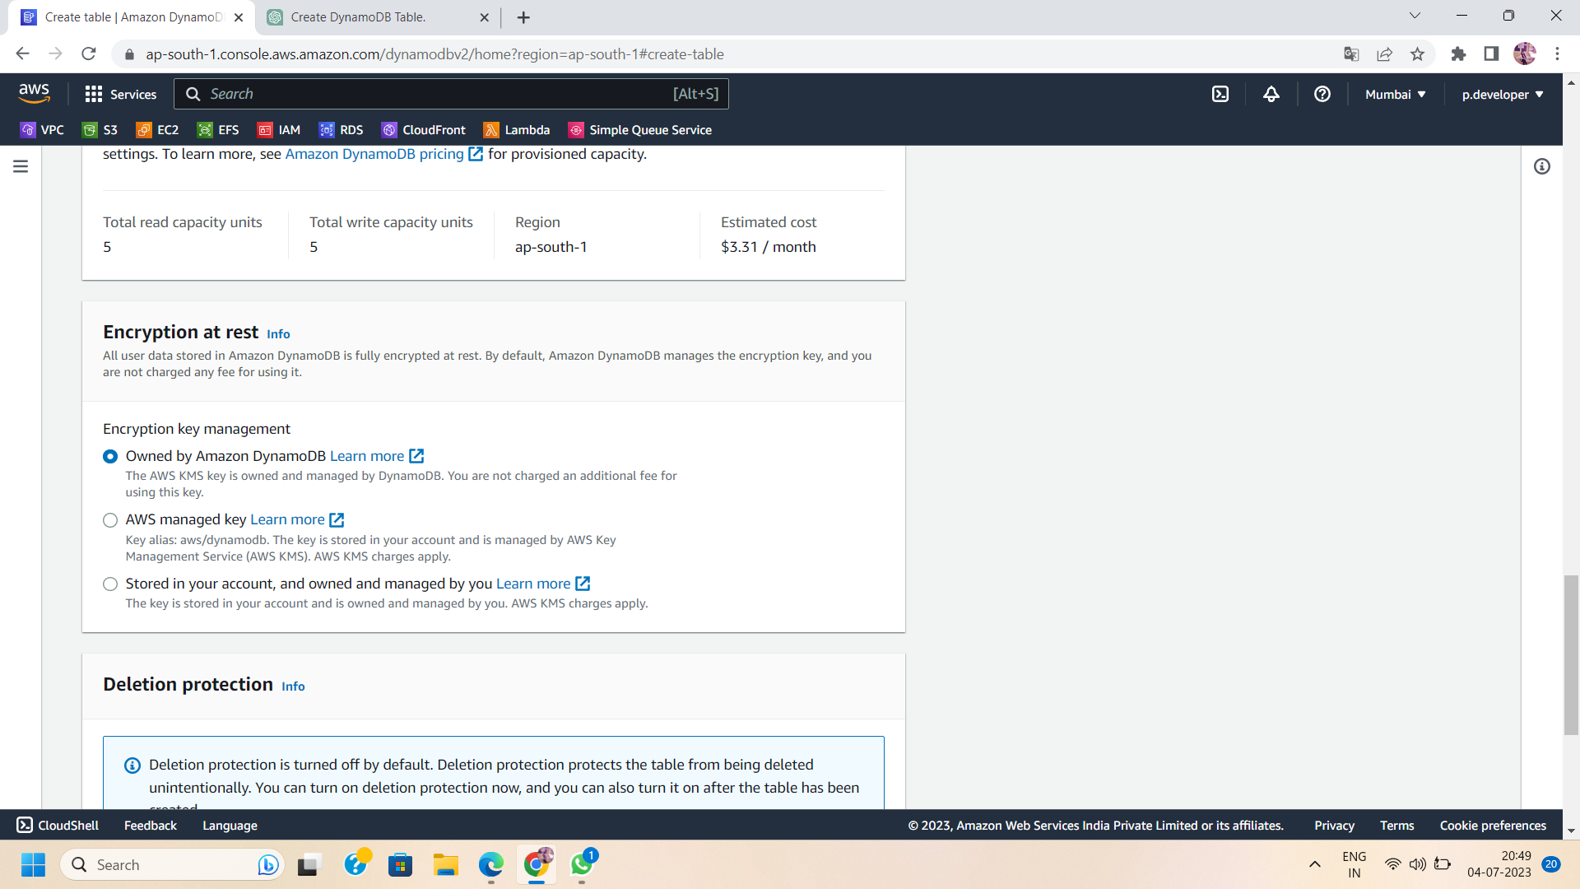

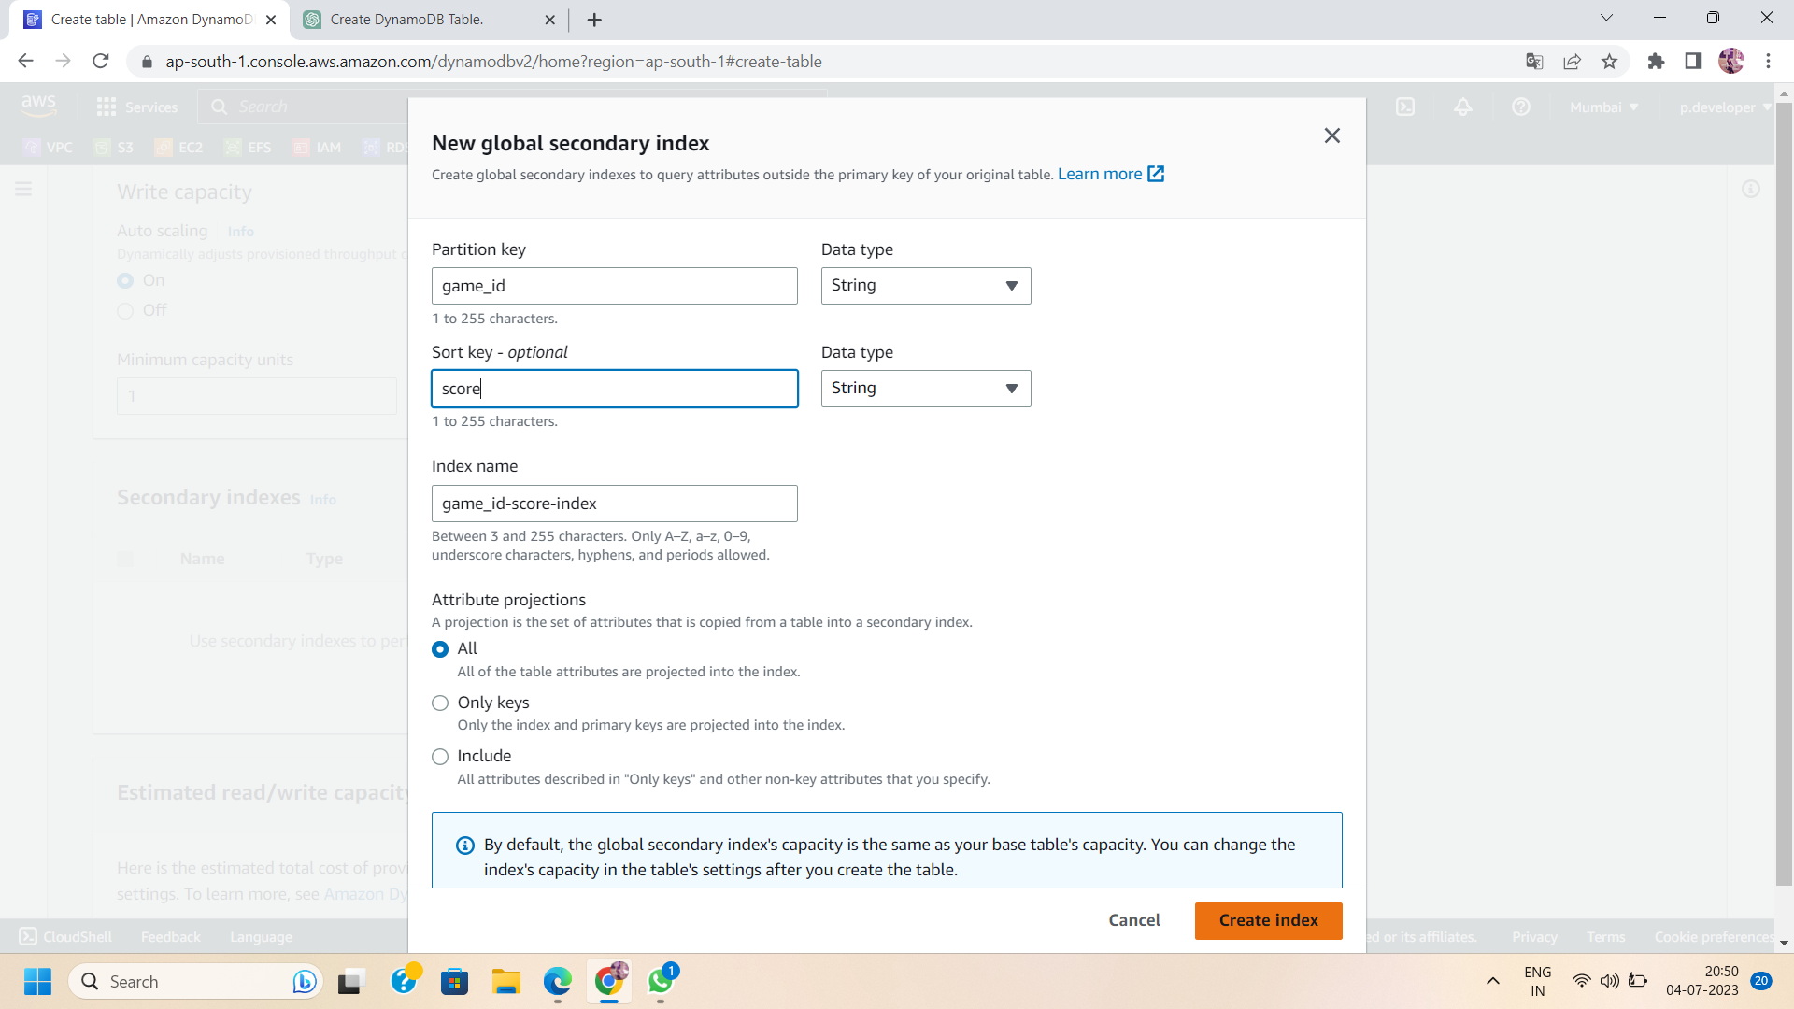

1. Review the settings and click on "Create" to create the table.

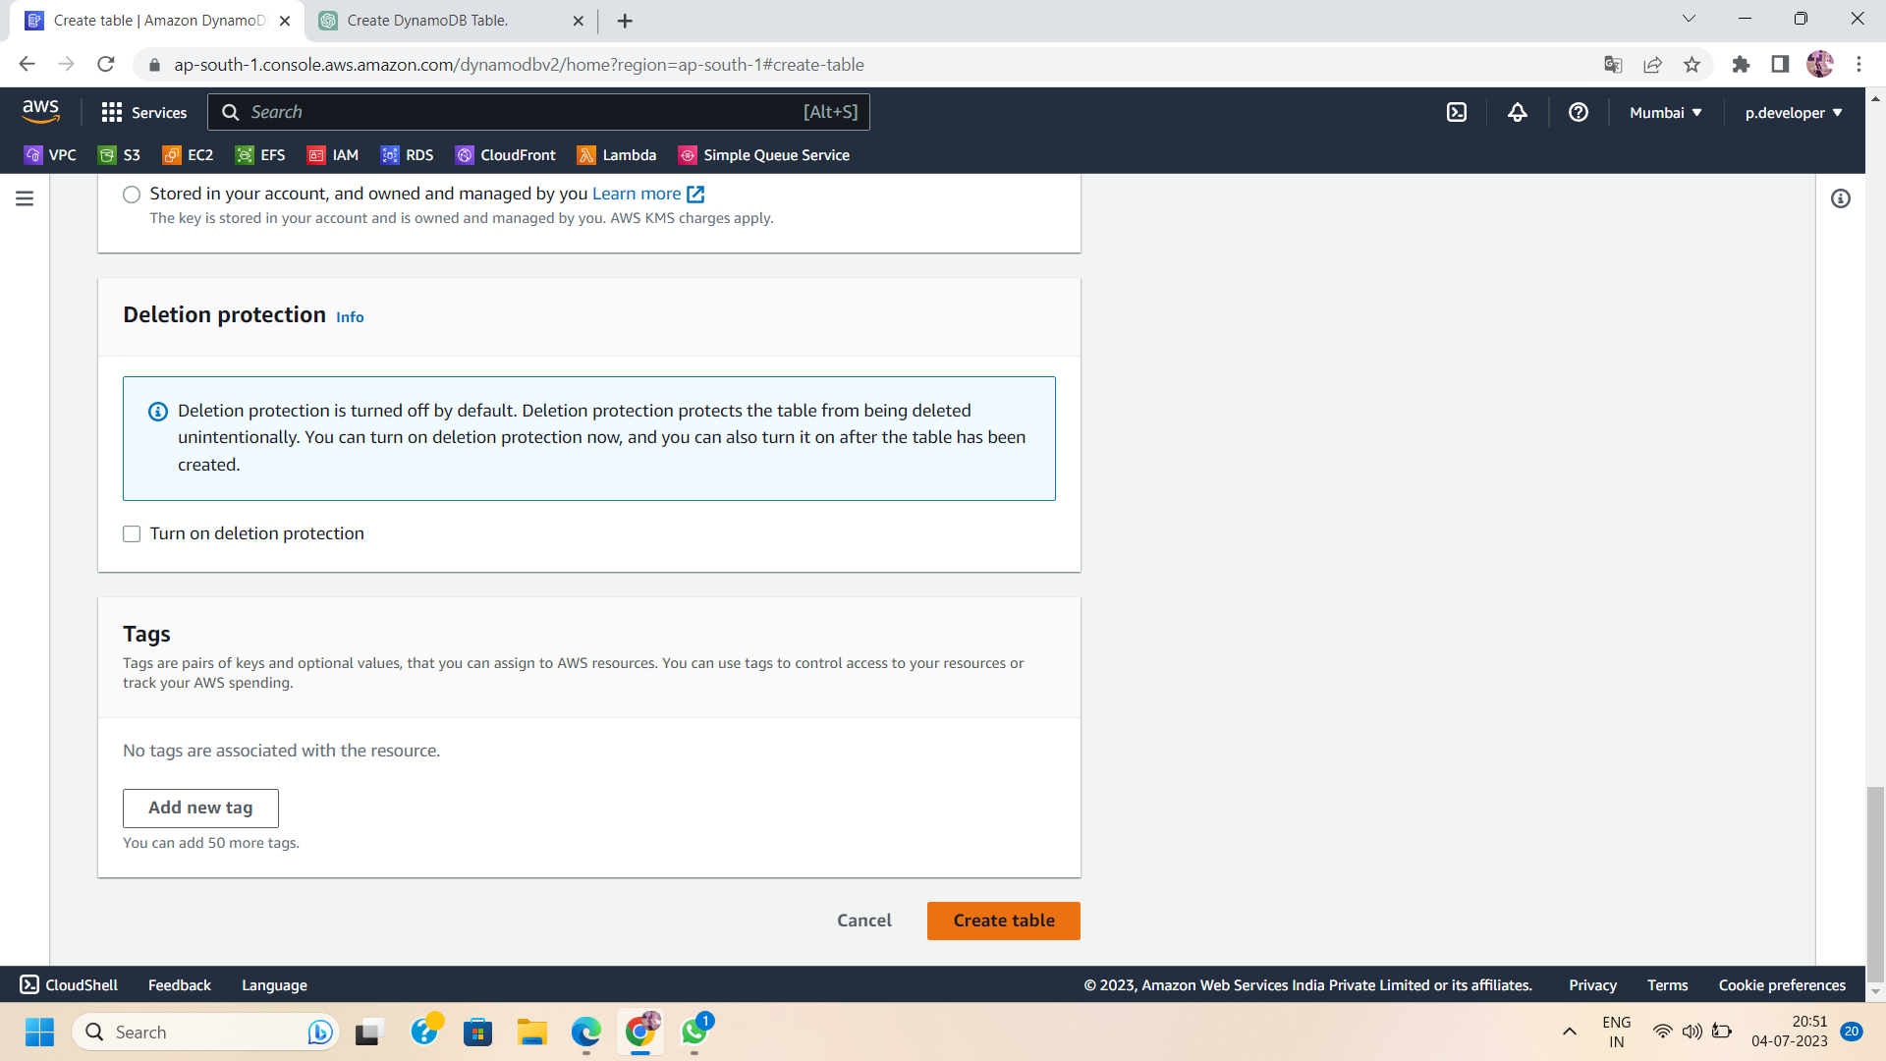

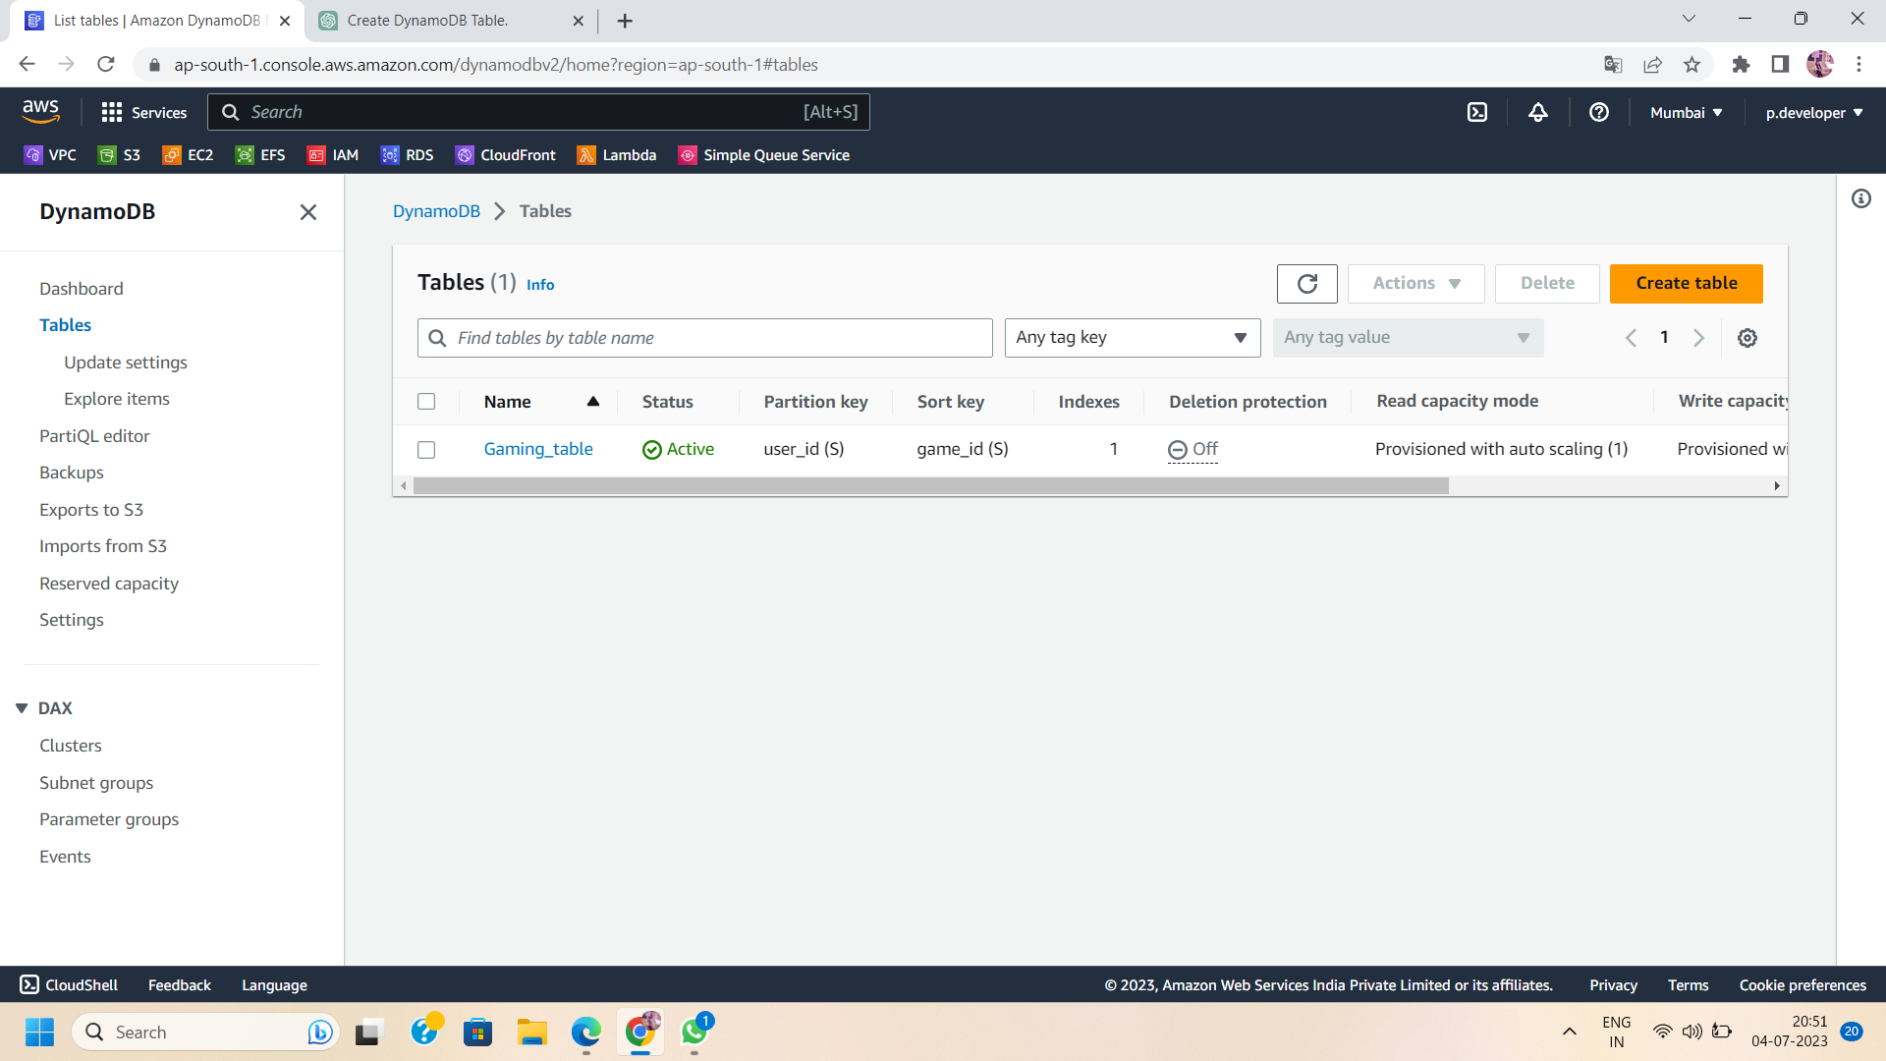

1. Once the table is created, you can start adding items to it using the provided APIs or SDKs.

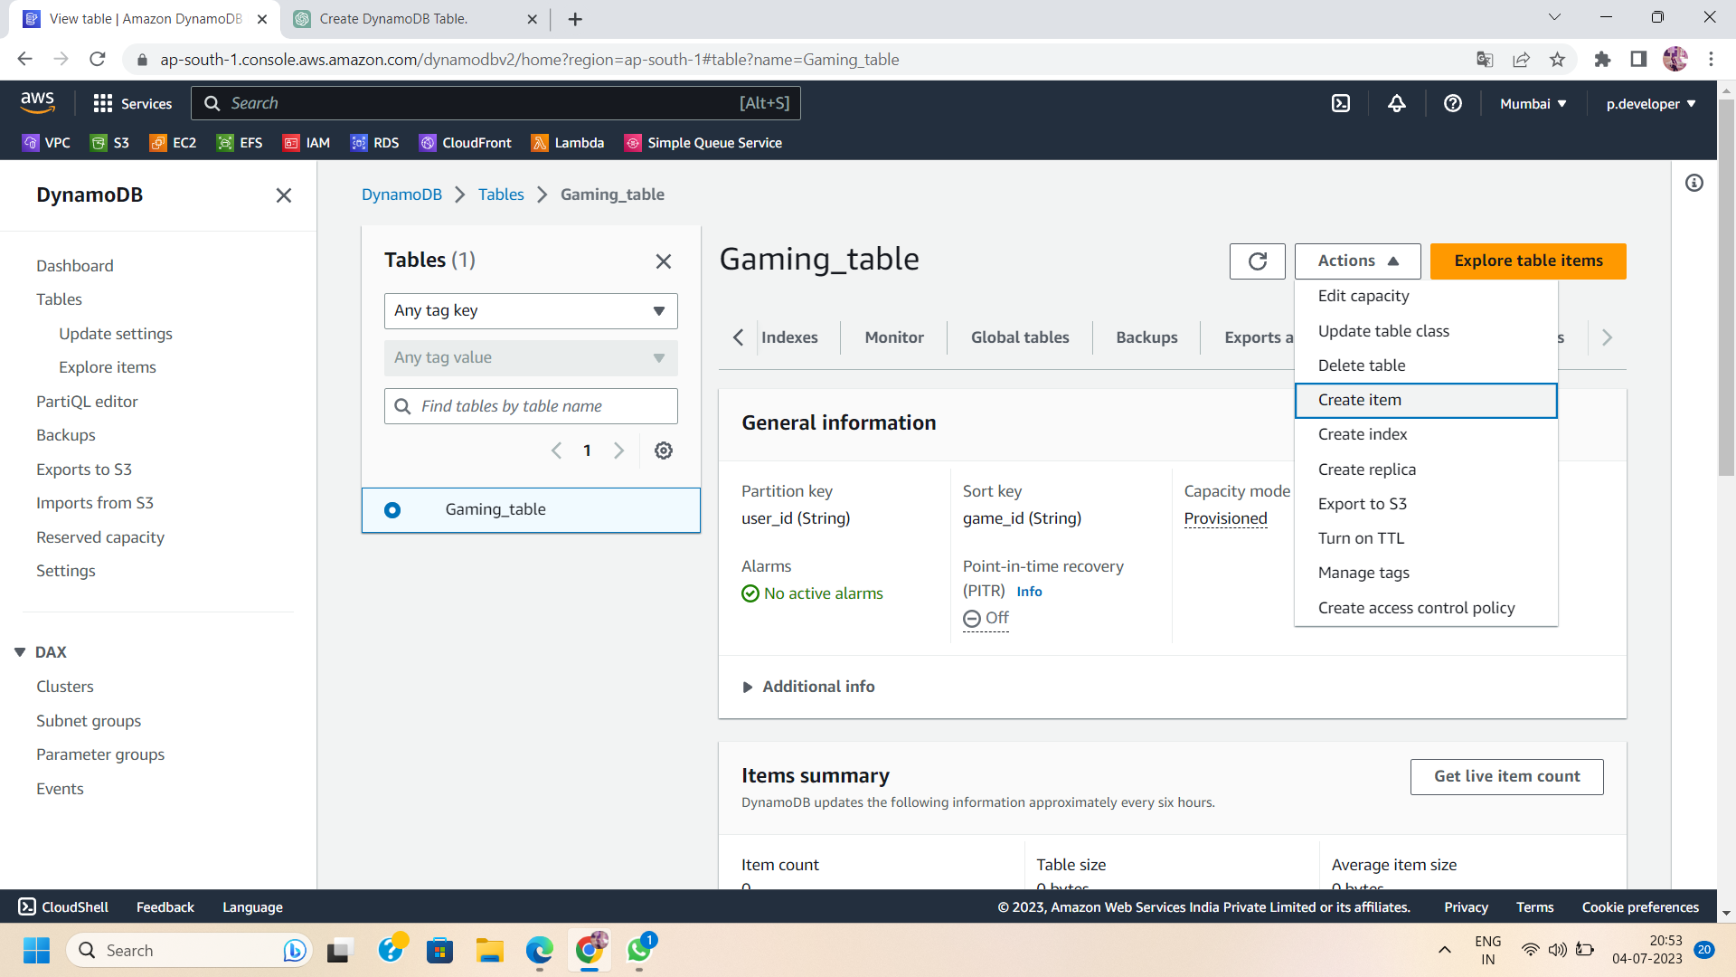

1. You can create table items in two ways :Form or json view.

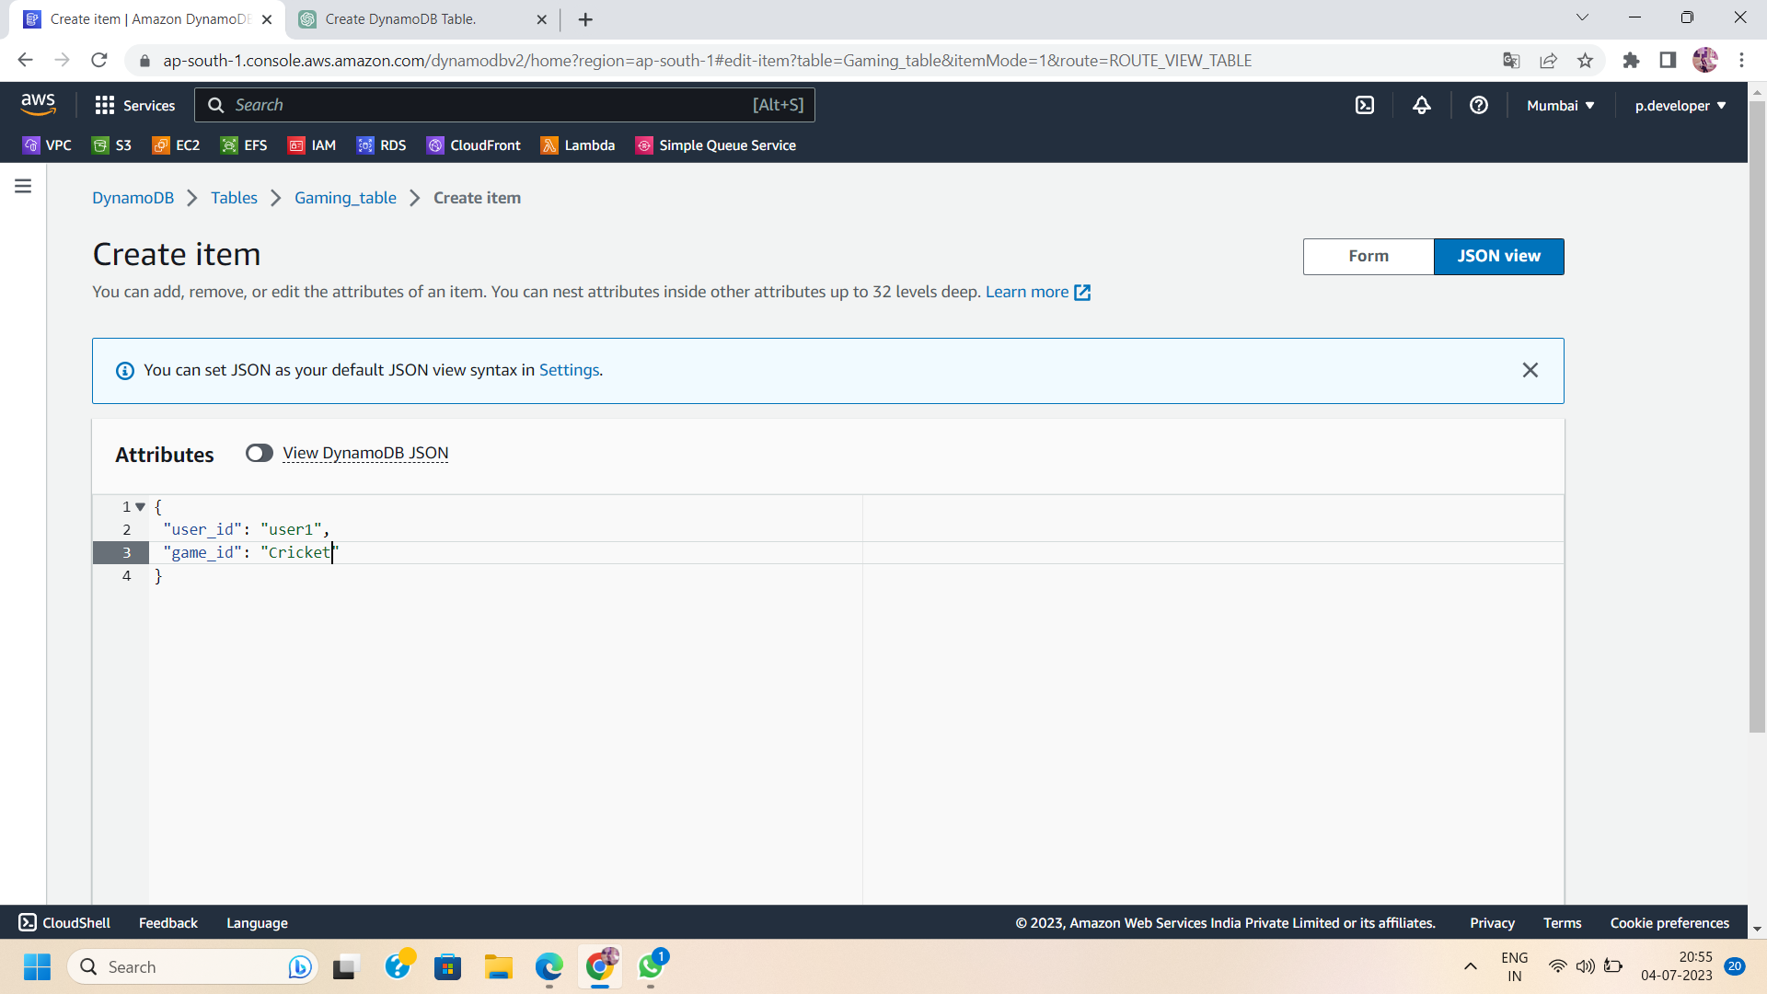

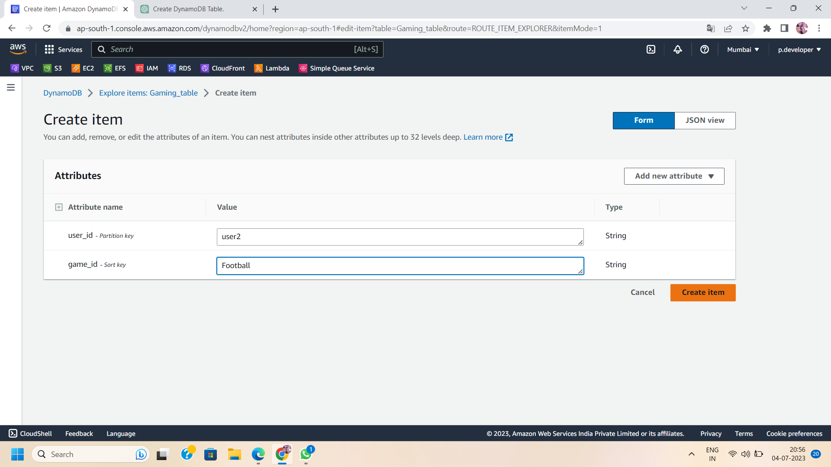

1. You can add any additional attributes you want to include in the table. These attributes can be used to store additional data associated with each item.

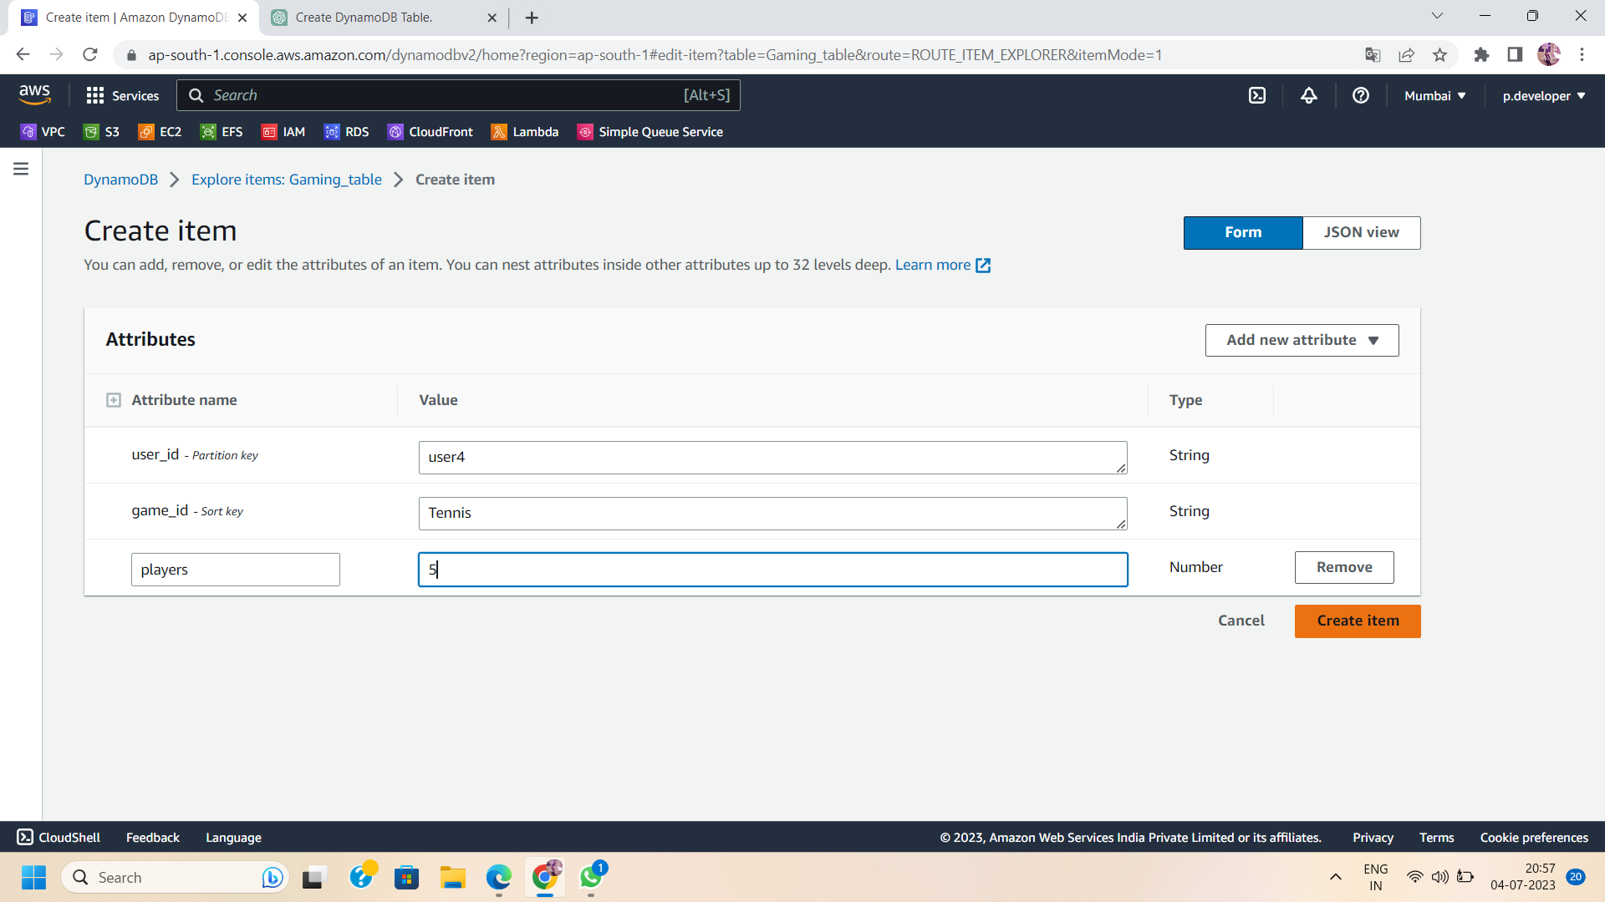

1. As DynamoDB has no predefined structure, we can add n number of attributes to individual items.

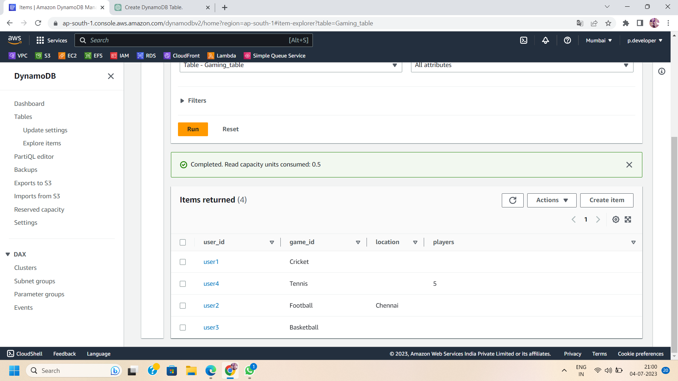

1. Repeat the above step to add more items to the table, providing unique values for the primary key attribute.
2. By following these steps, you can create a DynamoDB table and add items to it using the AWS Management Console or programmatically using the DynamoDB API or SDK. Remember to design your data model and choose appropriate primary keys and attributes based on your application's requirements and access patterns.